**LAN** stands for local area network. It is a group of network devices that allow communication between various connected devices. Private ownership has control over the local area network rather than the public. LAN has a short propagation delay than MAN as well as WAN. It covers smaller areas such as colleges, schools, hospitals, and so on.

**MAN** stands for metropolitan area network. It covers a larger area than LAN such as small towns, cities, etc. MAN connects two or more computers that reside within the same or completely different cities. MAN is expensive and should or might not be owned by one organization.

**WAN** stands for wide area network. It covers a large area than LAN as well as a MAN such as country/continent etc. WAN is expensive and should or might not be owned by one organization. PSTN or satellite medium is used for wide area networks. 

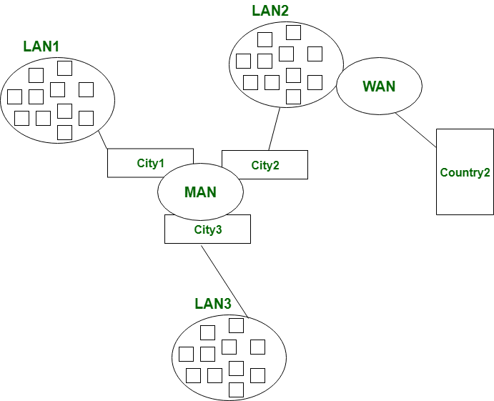

*Difference between LAN, MAN, and WAN*

**Differences between LAN, MAN, and WAN**

| **Basis** | **LAN** | **MAN** | **WAN** |
| --- | --- | --- | --- |
| **Full-Form** | [LAN](https://www.geeksforgeeks.org/lan-full-form/) stands for local area network. | [MAN](https://www.geeksforgeeks.org/man-full-form/) stands for metropolitan area network. | [WAN](https://www.geeksforgeeks.org/wan-full-form/) stands for wide area network. |
| **Geographic Span** | Operates in small areas such as the same building or campus. | Operates in large areas such as a city. | Operates in larger areas such as country or continent. |
| **Ownership** | LAN’s ownership is private. | MAN’s ownership can be private or public. | While WAN also might not be owned by one organization. |
| **Transmission Speed** | The transmission speed of a LAN is high. | While the transmission speed of a MAN is average. | Whereas the transmission speed of a WAN is low. |
| **Propagation delay** | The propagation delay is short in a LAN. | There is a moderate propagation delay in a MAN. | Whereas, there is a long propagation delay in a WAN. |
| **Congestion** | There is less congestion in LAN. | While there is more congestion in MAN. | Whereas there is more congestion than MAN in WAN. |
| **Design & Maintenance** | LAN’s design and maintenance are easy. | While MAN’s design and maintenance are difficult than LAN. | Whereas WAN’s design and maintenance are also difficult than LAN as well MAN. |
| **Fault tolerance** | There is more fault tolerance in LAN. | While there is less fault tolerance. | In WAN, there is also less fault tolerance. |

**Local Area Network (LAN) –**

LAN or Local Area Network connects network devices in such a way that personal computers and workstations can share data, tools, and programs. The group of computers and devices are connected together by a switch, or stack of switches, using a private addressing scheme as defined by the TCP/IP protocol. Private addresses are unique in relation to other computers on the local network. Routers are found at the boundary of a LAN, connecting them to the larger WAN.

Data transmits at a very fast rate as the number of computers linked is limited. By definition, the connections must be high-speed and relatively inexpensive hardware (Such as hubs, network adapters, and Ethernet cables). LANs cover a smaller geographical area (Size is limited to a few kilometres) and are privately owned. One can use it for an office building, home, hospital, school, etc. LAN is easy to design and maintain. A Communication medium used for LAN has twisted-pair cables and coaxial cables. It covers a short distance, and so the error and noise are minimized.

Early LANs had data rates in the 4 to 16 Mbps range. Today, speeds are normally 100 or 1000 Mbps. Propagation delay is very short in a LAN. The smallest LAN may only use two computers, while larger LANs can accommodate thousands of computers. LAN has a range up to 2km. A LAN typically relies mostly on wired connections for increased speed and security, but wireless connections can also be part of a LAN. The fault tolerance of a LAN is more and there is less congestion in this network. For example A bunch of students playing Counter-Strike in the same room (without internet).

#### **Advantages:**

* Provides fast data transfer rates and high-speed communication.
* Easy to set up and manage.
* Can be used to share peripheral devices such as printers and scanners.
* Provides increased security and fault tolerance compared to WANs.

#### **Disadvantages:**

* Limited geographical coverage.
* Limited scalability and may require significant infrastructure upgrades to accommodate growth.
* May experience congestion and network performance issues with increased usage.

### Metropolitan Area Network (MAN) –

MAN or Metropolitan area Network covers a larger area than that covered by a LAN and a smaller area as compared to WAN. MAN has a range of 5-50km. It connects two or more computers that are apart but reside in the same or different cities. It covers a large geographical area and may serve as an ISP (Internet Service Provider). MAN is designed for customers who need high-speed connectivity. Speeds of MAN range in terms of Mbps. It’s hard to design and maintain a Metropolitan Area Network.

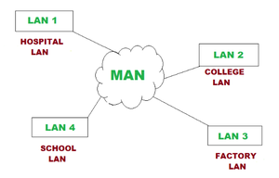

The fault tolerance of a MAN is less and also there is more congestion in the network. It is costly and may or may not be owned by a single organization. The data transfer rate and the propagation delay of MAN are moderate. Devices used for transmission of data through MAN are Modem and Wire/Cable. Examples of a MAN are part of the telephone company network that can provide a high-speed DSL line to the customer or the cable TV network in a city.

#### **Advantages:**

* Provides high-speed connectivity over a larger geographical area than LAN.
* Can be used as an ISP for multiple customers.
* Offers higher data transfer rates than WAN in some cases.

#### **Disadvantages:**

* Can be expensive to set up and maintain.
* May experience congestion and network performance issues with increased usage.
* May have limited fault tolerance and security compared to LANs.

### Wide Area Network (WAN) –

WAN or Wide Area Network is a computer network that extends over a large geographical area, although it might be confined within the bounds of a state or country. WAN has a range of above 50 km. A WAN could be a connection of LAN connecting to other LANs via telephone lines and radio waves and may be limited to an enterprise (a corporation or an organization) or accessible to the public. The technology is high-speed and relatively expensive.

There are two types of WAN: Switched WAN and Point-to-Point WAN. WAN is difficult to design and maintain. Similar to a MAN, the fault tolerance of a WAN is less and there is more congestion in the network. A Communication medium used for WAN is PSTN or Satellite Link. Due to long-distance transmission, the noise and error tend to be more in WAN.

WAN’s data rate is slow about a 10th LAN’s speed since it involves increased distance and increased number of servers and terminals etc. The speed of WAN ranges from a few kilobits per second (Kbps) to megabits per second (Mbps). Propagation delay is one of the biggest problems faced here. Devices used for the transmission of data through WAN are Optic wires, Microwaves, and Satellites. An example of a Switched WAN is the asynchronous transfer mode (ATM) network and Point-to-Point WAN is a dial-up line that connects a home computer to the Internet.

#### **Advantages:**

* Covers large geographical areas and can connect remote locations.
* Provides connectivity to the internet.
* Offers remote access to resources and applications.
* Can be used to support multiple users and applications simultaneously.

#### **Disadvantages:**

* Can be expensive to set up and maintain.
* Offers slower data transfer rates than LAN or MAN.
* May experience higher latency and longer propagation delays due to longer distances and multiple network hops.
* May have lower fault tolerance and security compared to LANs.

A computer network is a system that connects numerous independent computers in order to share information (data) and resources. In this article, we will see the advantages and disadvantages of  LAN, MAN, and WAN.

**Advantages of LAN**

* **Simple and reasonable cost:**The primary benefit of the [local area network](https://www.geeksforgeeks.org/lan-full-form/)is that is immediate and easy to set up and also its price is minimum.
* **Accessing of software program:**With the help of LAN, software programs are also shared. You can incorporate a single licensed program that can be used by any device on a network. It is very costly to buy a license for every device on a network, consequently sharing software is a simple and straightforward way.
* **Data protection:**Data protection is a safe and secure way to keep information on the server. Here if you wish to update or eliminate any data, you can do so rapidly on a single server computer and other devices are obtain to new information.
* **Fast communication:**LAN-connected system to communicate directly at very high speed, based on the LAN model and installed ethernet cabling. The most prevalent enabled speed is 10Mbps, 100Mbps, and 1000Mbps.

**Disadvantages of LAN**

* **Limited distance:**Local area networks are used only in buildings or apartment complexes it cannot be occupied in bigger areas.
* **Information security issue created:**If the server equipment is not programmed correctly then unapproved users can retrieve data and there is a technical mistake. There arise issues like server privacy.
* **Installing LAN is expensive:**It is expensive to establish a LAN. Here specialized software is essential to install a server. Communication hardware such as hubs, switches, routers, and cables are expensive to buy.
* **Data sharing via outside source:**It is difficult and time-consuming to send files from outside the network since transportable media like pen drives and CDs cannot be easily performed on all devices on the network.
* **Limited scalability**: LANs are limited in terms of the number of devices that can be connected to them. As the number of devices increases, the network can become slow and congested.
* **Single point of failure:** LANs typically have a single point of failure, such as a central server. If this server fails, the entire network can go down.
* **Maintenance and management**: LANs require regular maintenance and management to ensure optimal performance. This can be time-consuming and costly.

**Advantages of MAN**

* **Security:**[MAN](https://www.geeksforgeeks.org/man-full-form-in-computer-networking/) provides more security as compared to WAN and it is easy to implement.
* **Distance occupies:**MAN is occupied more distance as compared to LAN i.e. It is wider than LAN.
* **Less expensive:**MAN implementation cost is less than WAN because MAN requires fewer resources as compared to WAN. It saves implementation costs.
* **High speed:**Man has a high speed of data transfer because MAN often uses fiber optics cables that are capable of offering speeds up to 1000Mbps.
* **Centralized management:** MANs can be centrally managed, making it easier to monitor and control network traffic.
* **Cost-effective**: Compared to WANs, MANs are more cost-effective to implement and maintain.
* **Scalability**: MANs can be easily scaled up or down to meet changing business needs.
* **Improved communication**: MANs can improve communication within organizations by allowing for faster and more efficient sharing of data and resources.



**Disadvantages of MAN**

* **The problem of less security:**It is difficult to secure the system from hackers because of the large area. This is mainly due to safety issues.
* **Wire required:**more cables are required to connect MAN from one place to another. MAN requires fiber optics cables which are quite expensive.
* **Technical assistance:**Here, skilled technicians and administrators are required. This can overall increase the installation cost.
* **Difficult to manage:**MAN consumes a large area then there is difficult to manage a large network, Here is a chance of attacking hackers on the network. Data can be secured but it needs experienced staff and security tools.

**Advantages of WAN**

* **Large area coverage:**[WAN](https://www.geeksforgeeks.org/wan-full-form/) covers a large geographical area(1000 km or more than). Ex. If your business office is situated in another country and you live in another country then WAN is a platform to communicate with each other(i.e. you and your office staff members).
* **Higher bandwidth:**WAN networks usually cover large geographical areas. Ex.1000 km or more than the wide area network has higher bandwidth than LAN and MAN networks.
* **Centralized data:**Using the WAN network you can share the data connected to all the devices in the respective network. Ex. By using the WAN network, all branches are capable to share all data through the head office server and you can get support, full backup, and other precious data from the head office, and all data gets synchronized along with all other company branches.
* **Message Exchange:**With the help of the Internet Of Things (IoT) and LAN, a sudden growth of WAN-based devices can be seen. This communication via message can be done fastest with the help of the most popular apps like messenger and WhatsApp.

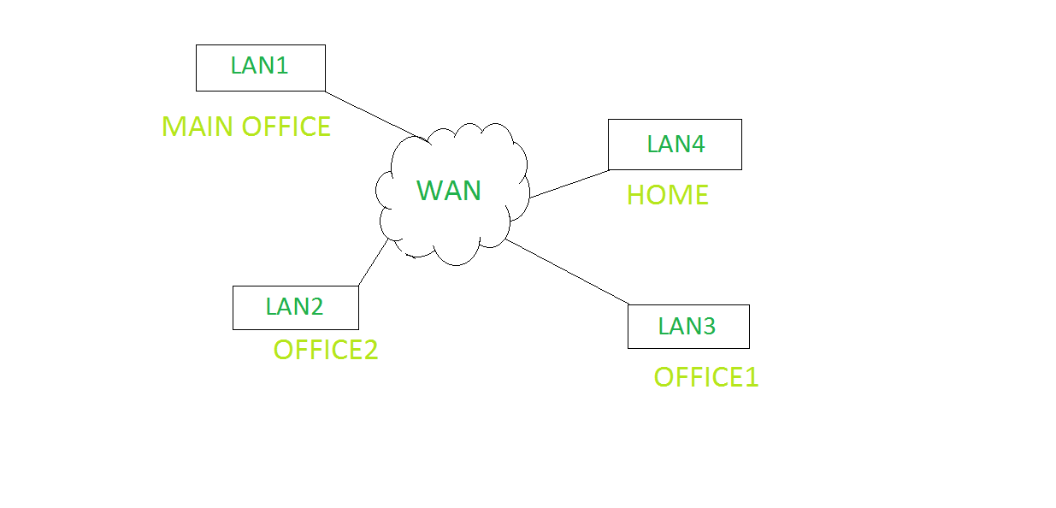

**Disadvantages of WAN**

* **Security issue:**WAN faces more security problems than LAN and MAN networks due to WAN networks more technologies are merged. It can open a security gap, which paves the way of occurring malicious attacks and identity intruders.
* **Installation cost:**WANs are default complex and complicated because of large geographical area coverage. Hence there is a set-up cost in expensive WAN that also needs routers, switches, and other security solutions.
* **Troubleshooting issues:**Troubleshoot the big challenge on the WAN network and it requires more time. If any issue occurs in the computer network then it is the most difficult part to find out the proper cause due to their broad coverage area.
* **Maintenance issues:**In a WAN network, it is difficult to maintain the network especially a data center that operates 24/7 is the biggest challenge out of all. Here 24/7 needs assistance from network administrators and technicians. In a WAN, maintenance cost is high.